South East Technological University

University App
Functional Specification

Prepared by:
Ihor Melashchenko (C00290950)
Bachelor of Science (Honours) in Software Development, Year 4
Supervisor:
Dr. Joseph Kehoe
19.05.2026

Acknowledgements
Thank you to the project supervisor and peer reviewers for iterative feedback on scope control and implementation quality.

Table of Contents
Acknowledgements 2
Abstract 5
1. Introduction 6
1.1 Purpose 6
1.2 Scope 6
1.3 System Context 6
2. Users 7
3. Product Description 8
3.1 Core Functional Areas 8
3.2 Feature Prioritization 8
4. Functional Requirements 9
5. Use Cases 11
6. Non-Functional Requirements (FURPS) 16
7. Metrics and Success Criteria 17
8. Project Plan Summary 18
9. Precedent and Differentiation 19
9.1 Existing Similar Systems 19
9.2 Differentiation 19
10. Assumptions and Constraints 20
11. Risks 21
Glossary 22
Bibliography 23

Figure 1. Context Diagram 6
Figure 2. Use Case Diagram 11

Abstract
The University App is a multi-platform super-app (Haines, 2022) that consolidates student services into a single, unified platform. The long-term vision is that the application could operate as a configurable B2B (business-to-business) service for any higher education institution (HEI), similar to how Blackboard functions as a SaaS (Software as a Service) product.
For this project, the development focuses on the ecosystem of the South East Technological University (SETU), incorporating its branding, structure, and service offerings.
The application aims to address a widely recognized challenge across HEIs: fragmented student systems that require multiple logins, offer an inconsistent user experience, and have limited integration.
Project motto: “One app. One login. One student experience.”

1. Introduction

1.1 Purpose
This specification defines the system scope, users, use cases, functional requirements, and measurable success criteria. The goal is to ensure that implementation and assessment are aligned to explicit requirements.

1.2 Scope
In scope:
- Go RESTful APIs for student and staff workflows
- PostgreSQL database
- React admin portal for operations
- iOS client for student usage
- Security via JWT-based authentication and role authorization
Out of current scope:
- Production single sign-on (SSO) integration with HEI provider
- Android and web clients
- Offline synchronization
- Push notifications

1.3 System Context
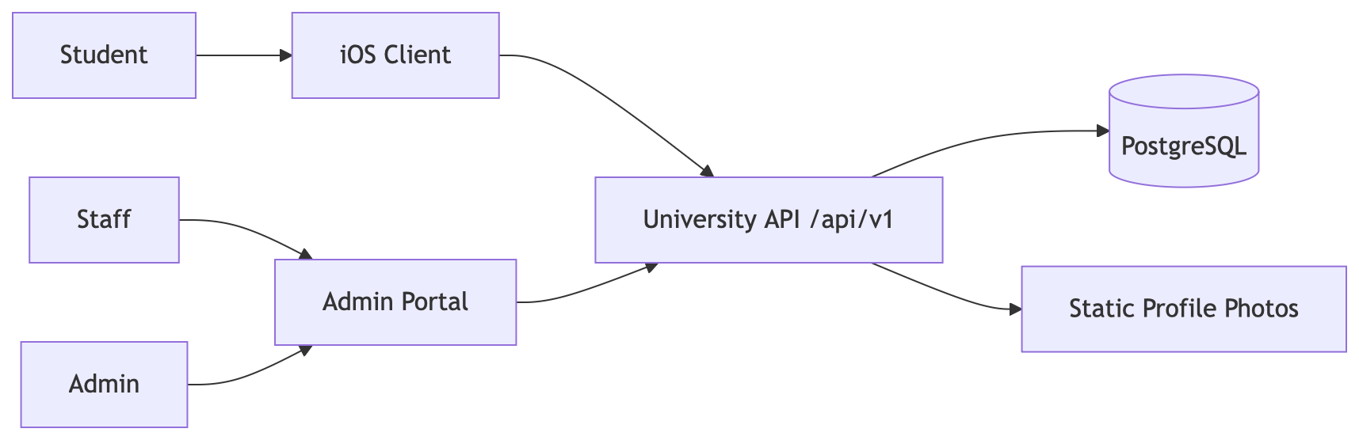
Figure 1. Context Diagram

2. Users
- Student
- Staff
- Admin

3. Product Description

3.1 Core Functional Areas
- Authentication and authorization
- Student profile
- Digital student ID (QR/barcode verification)
- Card request lifecycle
- Assignment tracking and submission
- Feedback and telemetry collection
- Admin oversight and staff management

3.2 Feature Prioritization
Mandatory
- Student login with JWT token issuance
- Staff login with JWT token issuance
- Student profile retrieval
- QR code and barcode generation and verification path
- Card request submission and status tracking
- Assignment list and submission endpoint
- Admin card request processing (approve/reject)
- Persistent data model with migrations
Discretionary
- Filterable admin dashboards for assignments, feedback, and telemetry
- Rich profile model including memberships
- Seeded demo data and repeatable local environment
- Kubernetes deployment manifests with local/prod overlays
Exceptional
- Multi-client architecture (API + admin portal + native iOS client)
- Release-quality deployment workflow and reproducible environment

4. Functional Requirements
ID | Requirement | Priority | Verification
FR-01 | System shall authenticate students by student number and password. | Must | API test: POST /api/v1/login
FR-02 | System shall authenticate staff by staff number and password. | Must | API test: POST /api/v1/staff/login
FR-03 | System shall provide authenticated student their profile data. | Must | API test: GET /api/v1/student-info
FR-04 | System shall generate student QR code and barcode. | Must | API tests: GET /api/v1/qr-code, GET /api/v1/barcode
FR-05 | System shall verify submitted identity code payloads. | Must | API test: POST /api/v1/verify
FR-06 | System shall support student card request submission and status query. | Must | API tests: POST /api/v1/card/requests, GET /api/v1/card/status
FR-07 | System shall allow admin card request processing. | Must | API tests: GET /api/v1/admin/card-requests, POST /api/v1/admin/card-requests/{id}/process
FR-08 | System shall provide assignment listing and submission. | Must | API tests: GET /api/v1/assignments, GET /api/v1/assignments/{id}, POST /api/v1/assignments/{id}/submit
FR-09 | System shall collect student feedback and telemetry events. | Must | API tests: POST /api/v1/feedback, POST /api/v1/telemetry/events
FR-10 | System shall provide admin views for assignments, feedback, and telemetry with filters. | Should | API tests: /api/v1/admin/*
FR-11 | System shall support admin staff account management. | Should | API tests: GET/POST/PATCH /api/v1/admin/staff*
FR-12 | System shall persist domain entities in PostgreSQL with migration history. | Must | Migration audit and runtime database checks.

5. Use Cases
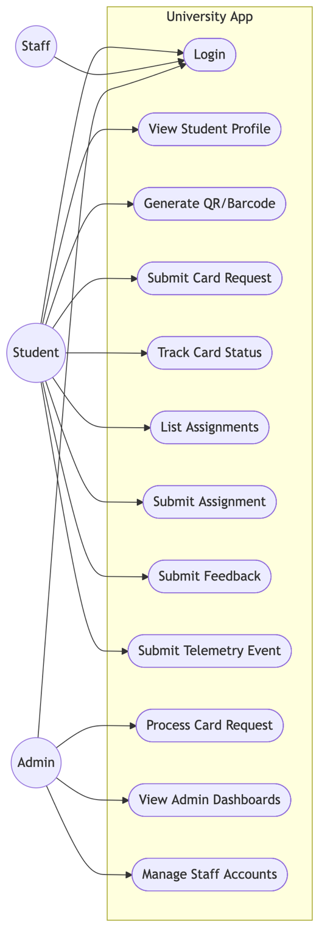
Figure 2. Use Case Diagram
UC-01 Student Login
- Primary actor: Student
- Trigger: Student submits credentials
- Preconditions: Student account exists and is active
- Main flow:
  - Student submits student number and password
  - API validates credentials
  - API returns JWT token
- Alternate flow:
  - Invalid credentials
  - HTTP 401 response
- Postconditions: Student has a valid bearer token
- Traceability: FR-01

UC-02 Staff Login
- Primary actor: Staff/Admin
- Trigger: Staff submits credentials
- Preconditions: Staff account exists
- Main flow:
  - Staff submits staff number and password
  - API validates credentials and role
  - API returns JWT token
- Alternate flow:
  - Invalid credentials
  - HTTP 401 response
- Postconditions: Staff token includes claims required for authorization
- Traceability: FR-02

UC-03 View Student Profile
- Primary actor: Student
- Trigger: Student opens digital student ID page
- Preconditions: Student authenticated
- Main flow:
  - Student requests QR code and barcode
  - API signs and generates images
  - Client displays codes for verification
- Alternate flow:
  - Generation error
  - HTTP 500 response with message
- Postconditions: Digital student ID available for scanning
- Traceability: FR-04, FR-05

UC-05 Submit Card Request
- Primary actor: Student
- Trigger: Student selects new/replacement card request
- Preconditions: Student authenticated
- Main flow:
  - Student submits the request payload
  - API validates the payload and stores the request
  - Student checks status endpoint
- Alternate flow:
  - Invalid payload
  - HTTP 400 response
- Postconditions: Card request recorded with status
- Traceability: FR-06

UC-06 Process Card Request
- Primary actor: Admin
- Trigger: Admin reviews pending queue
- Preconditions: Admin authenticated with admin role
- Main flow:
  - Admin lists pending requests
  - Admin submits an approve/reject decision
  - API updates status and audit fields
- Alternate flow:
  - Non-admin token
  - HTTP 403 response
- Postconditions: Request status updated and visible to the student
- Traceability: FR-07

UC-07 Submit Assignment
- Primary actor: Student
- Trigger: Student opens the assignment and submits it
- Preconditions: Student authenticated, assignment exists
- Main flow:
  - Student retrieves the assignment list
  - Student submits assignment payload
  - API stores submission state
- Alternate flow:
  - Assignment not found
  - HTTP 404 response
- Postconditions: Submission recorded
- Traceability: FR-08

UC-08 Submit Feedback
- Primary actor: Student
- Trigger: Student completes feedback form
- Preconditions: Student authenticated
- Main flow:
  - Student submits feedback payload
  - API validates and persists the entry
  - Admin can later query entries
- Alternate flow:
  - Invalid payload
  - HTTP 400 response
- Postconditions: Feedback entry stored
- Traceability: FR-09, FR-10

UC-09 Telemetry Event Ingestion
- Primary actor: Student client
- Trigger: Client emits event
- Preconditions: Student authenticated
- Main flow:
  - Client sends event payload
  - API validates and persists the telemetry row
  - Admin queries the telemetry endpoint
- Alternate flow:
  - Invalid event format
  - HTTP 400 response
- Postconditions: Event available for analytics
- Traceability: FR-09, FR-10

UC-10 Staff Management
- Primary actor: Admin
- Trigger: Admin performs staff account operation
- Preconditions: Admin authenticated
- Main flow:
  - Admin lists staff accounts
  - Admin creates or updates the staff account
  - API persists role/state changes
- Alternate flow:
  - Validation error
  - HTTP 400 response
- Postconditions: Staff data updated
- Traceability: FR-11

6. Non-Functional Requirements (FURPS)
Category | Requirement | Target Metric | Measurement Method | Evidence Source
Functionality | Endpoint implement defined use cases and role checks. | 100% of mandatory use cases demonstrable. | API test checklist run before submission. | Route inventory and test evidence appendix
Usability | Student flows are understandable with low friction. | >= 80% of pilot users complete core tasks without assistance. | Structured usability walkthrough with task sheet. | Usability test log appendix
Reliability | Core API operations are stable under normal load. | >= 99% successful responses in controlled test window. | Scripted endpoint run with result capture. | Reliability test report appendix
Performance | Response times support interactive use. | p95 read endpoints <= 500 ms on local stack. | Timed API request sampling. | Performance table in final report
Supportability | Project can be set up/reproduced by assessors. | New machine setup in <= minutes from docs. | Dry-run setup using README steps. | Setup checklist evidence

7. Metrics and Success Criteria
- M-01: Authentication success rate >= 95% with valid credentials.
- M-02: Core endpoint p95 latency <= 500 ms in local Docker environment.
- M-03: Card request state transition correctness = 100 % for tested cases.
- M-04: Assignment submission success = 100% in tested normal flows.
- M-05: Role-protected endpoints reject unauthorized roles (expected HTTP 401/HTTP 403).

8. Project Plan Summary
Iteration | Deliverables | Current Position
First | Initial scope/users/context and requirement baseline | Completed
Second | Full use-case definitions, FURPS, and metrics | Completed
Third | Beta release | Completed
Final | Final release | Completed

9. Precedent and Differentiation

9.1 Existing Similar Systems
Existing learning management systems (LMS) and university systems commonly provide academic functions but are often split across multiple disconnected services.

9.2 Differentiation
- Unified API supporting identity verification, card requests, assignments, and feedback.
- Role-based, consistent admin endpoints.
- Multi-platform architecture with native iOS client and web admin portal

10. Assumptions and Constraints
- PostgreSQL remains the single source of truth.
- JWT secrets are managed via file-based runtime secrets.
- Demo credentials are for testing only.
- Network and infrastructure assumptions for the demo are pre-validated.

11. Risks
Risk | Impact | Mitigation
No automated unit tests currently planned | Reduced confidence in regression detection | Add focused test for handlers/repositories before submission
Potential differences between future user clients (Android, Web) and iOS | Reduced cross-platform user experience | Clearly identify goals and future-proof the system
Documentation mismatch with implementation | Inconsistent product | Maintain traceability table

Glossary
- API: Application Programming Interface
- JWT: JSON Web Token
- FURPS: Functionality, Usability, Reliability, Performance, Supportability
- p95: 95th percentile response time

Bibliography
Haines, J. (2022). The Super-app Experience. [online] Medium. Available at: https://uxplanet.org/the-super-app-experience-3fd530ac1e5f.

